**INDEX**

|  |  |  |
| --- | --- | --- |
| Sr.No. | Contents | Page No. |
| 1. | Introduction to project | 6 |
| 2. | Proposed System   * 1. Objectives   2. Requirement Engineering   3. Proposed System details   4. Hardware and Software Requirements | 7-10 |
| 3. | System Diagram   * 1. DFD   2. ERD | 11-12 |
| 4. | System Design  4.1 Database Design | 13-14 |
| 5. | Output Design | 15-17 |
| 6. | Conclusion and suggestions   * 1. Conclusion   2. Future enhancement | 18 |
| 7. | References and bibliography | 19 |

**INTRODUCTION**

With the advent of internet and globalization there are various technologies used by people. There are many platforms which gives is for use of these technologies. My project, YouTube Downloader will help people to get easily download video and many other options.

Through this project, aim to develop a system for YouTube Downloader which allow users to download videos as per their requirements. The application can be implemented in form of an android application with web view

The major aim of this project is to provide a solution for easily download a video. User can also save the time and also save the memory

**OBJECTIVES**

* + - To easily download a video
    - To save the time and memory
    - To download a video as per user’s requirement in any pixel
    - To download a video in your device memory
    - To get access of video offline

**Requirement Analysis**

The following is the detailed study of the requirements of the project.

* User should copy proper link of video to that textbox
* User should mention in which resolution video should download
* Feedback data will store in database

**Proposed System**

**Advantages of proposed system:**

* User friendly experience for user.
* User can easily download video, save device memory and time
* User can download video in any resolution ex. 360px, 480px, 720px etc.

# System Requirements

## Hardware Requirements

**Processor:** Intel(R) Core 2 Duo

**Installed Memory (RAM):** 1 GB RAM

**System Type:** 64-bit Operating System

## Software Requirements

**Operating System:** Windows 7 or above

### Integrated Development

**Environment (IDE):** Sublime Text Editor, Pycharm

**Front End:** HTML, CSS, javaScript

**Back End:** Python

**Database:** MySQL

### Note:-

The above mentioned are hardware and software requirements used to develop this project. A user (customer, admin) using this system only needs a compatible browser.

The hardware requirements are subject to change.

**System Diagrams**

* **DFD**

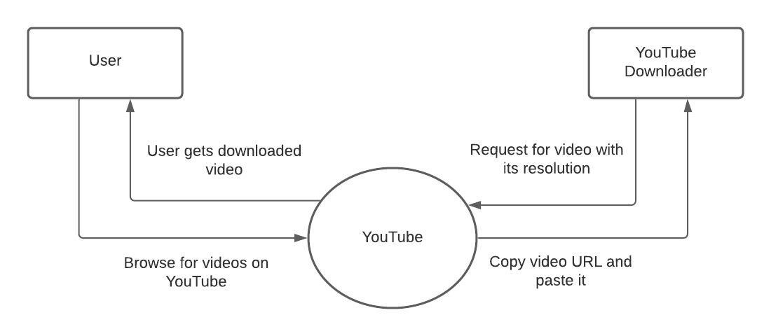

Fig. Data Flow Diagram for YouTube Downloader

* **ERD**

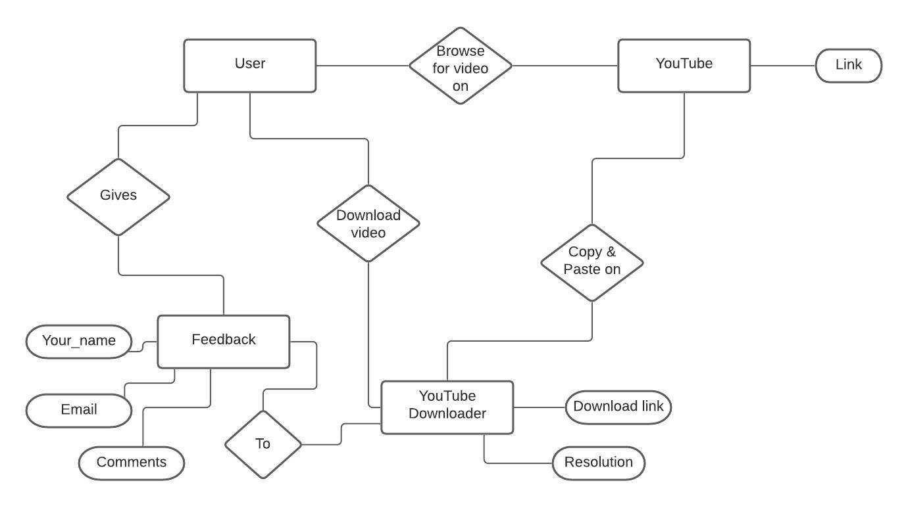

Fig. Entity Relation Diagram for YouTube Downloader

**SYSTEM DESIGN**

**1. Database Design**

Feedback:

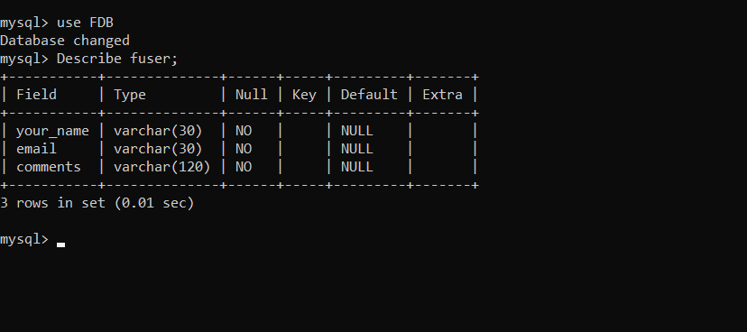

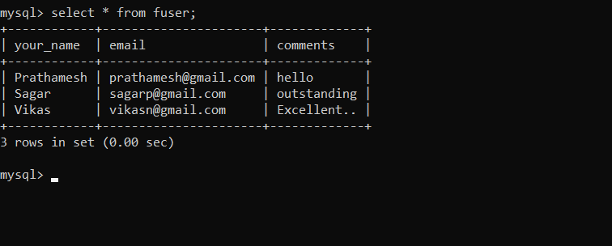

# Output Design

1. index.html

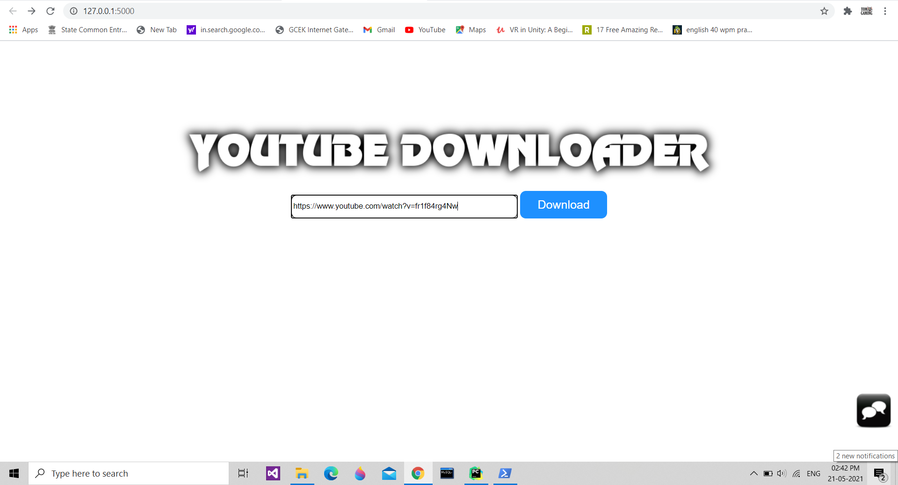

1. See_video.html

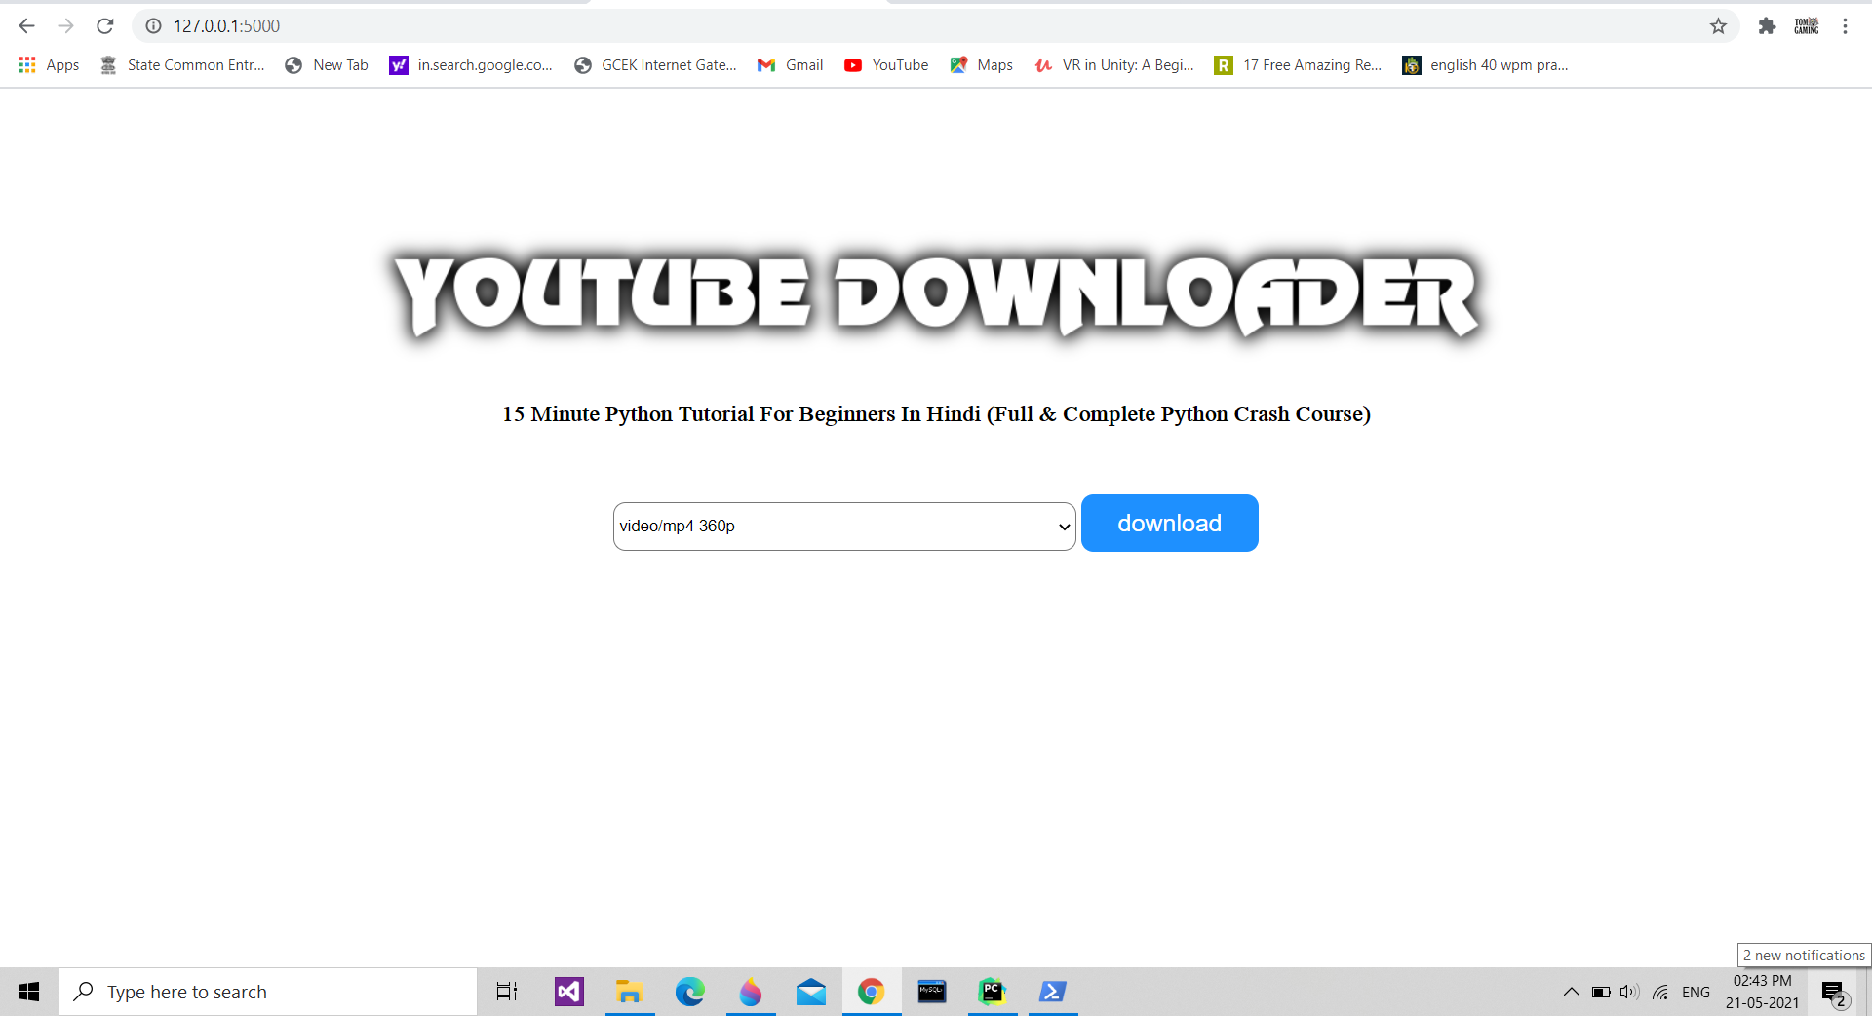

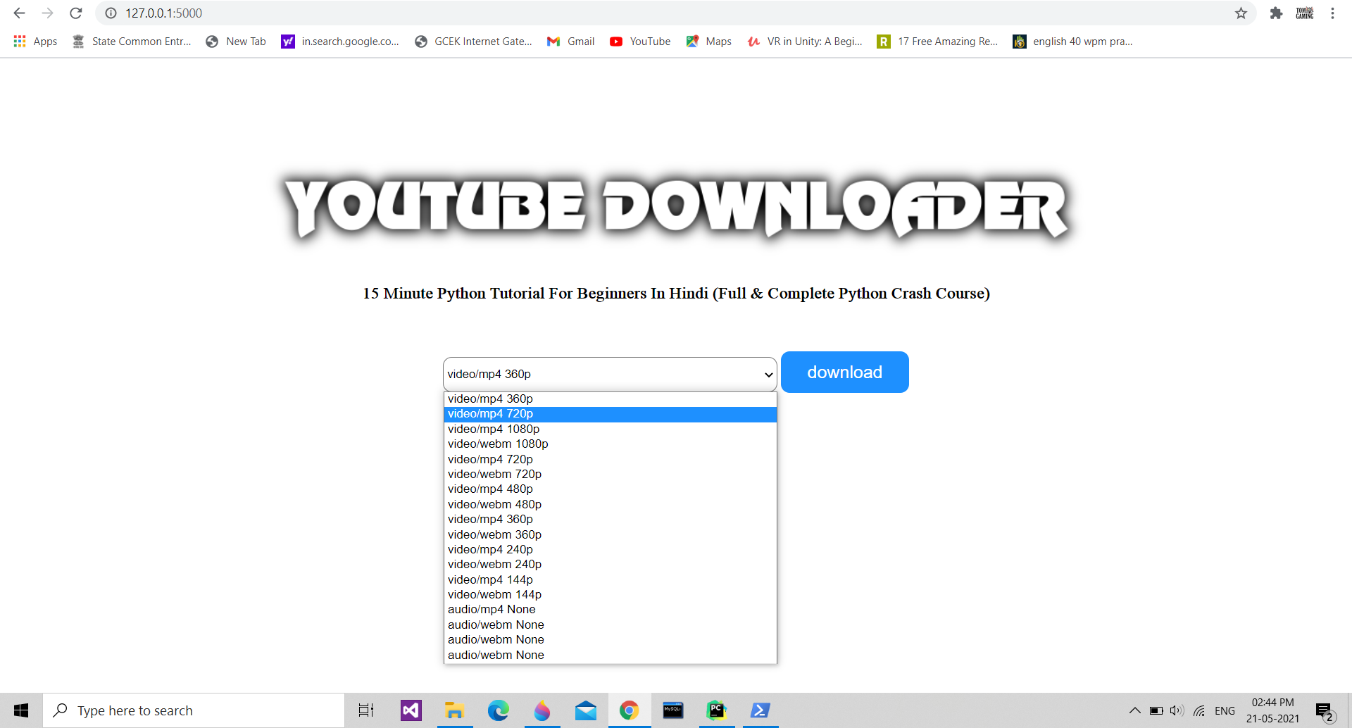

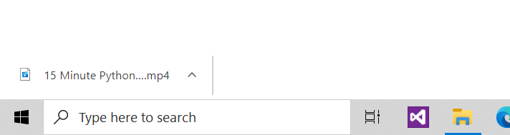

1. feedback.html

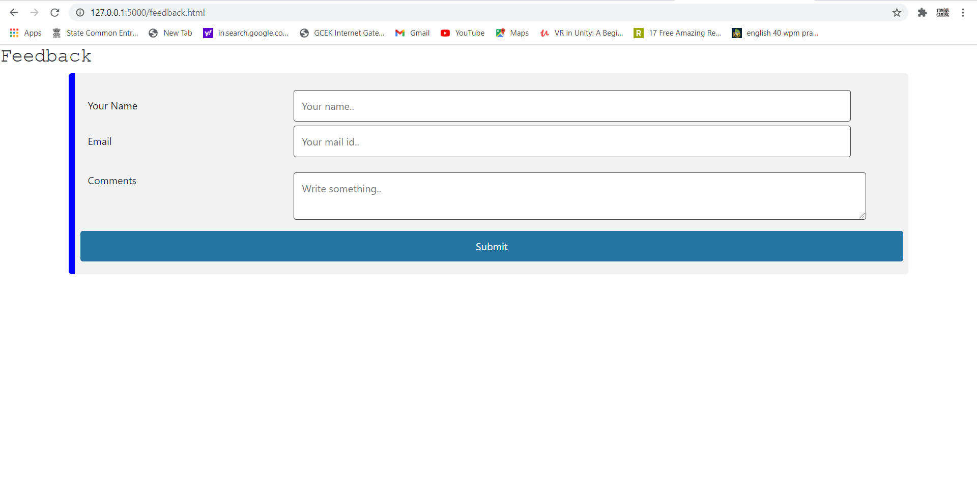

**Conclusion and future enhancement.**

The YouTube Downloader, is a web based application developed using python and mysql. Also because of the use of flask in UI designing, this website can be easily viewable . People can easily download video in just a click

Future enhancements to this project include a number of things.

* + Create a login page
  + SMS/ email confirmation
  + Video downloading from Instagram, Facebook

# References

#### References

1. YouTube

#### Websites

1. <https://getbootstrap.com/docs/4.3/getting-started/introduction/>
2. <https://www.w3schools.com/bootstrap/default.asp>
3. <https://www.codewithharry.com/>